**Monsanto Dicamba Volatility Low-Tunnel Studies**

* All trials were planted with NK S25-L9 soybeans at 140,000 seeds/acre.
* 30-inch rows at 1.5 in depth.
* PRE-herbicide was Warrant at 48 fl oz/acre + Tricor @ .33 lbs/acre



**Monsanto Dicamba Volatility Low-Tunnel 1**

Planted: 5/24/18

PRE: 5/26/18

Application (Flat): 06/28

Results presented at 14 and 28 DAT (days after treatment)

Photos taken at 28 DAT.

V4

17 cm





**XtendiMax w/Vaporgrip**

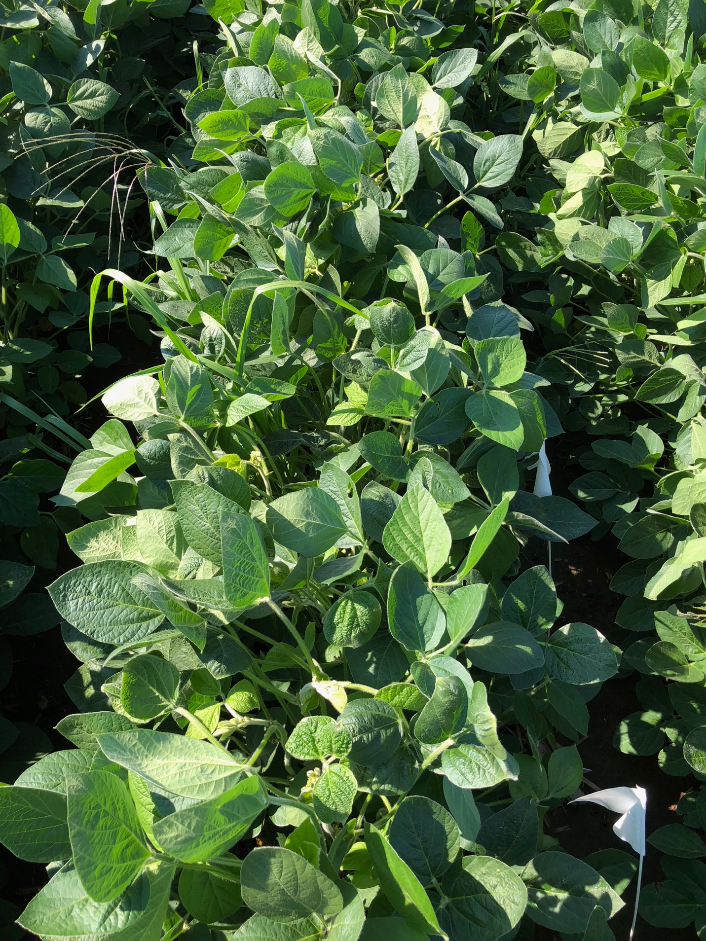

**XtendiMax w/Vaporgrip + Durango DMA**

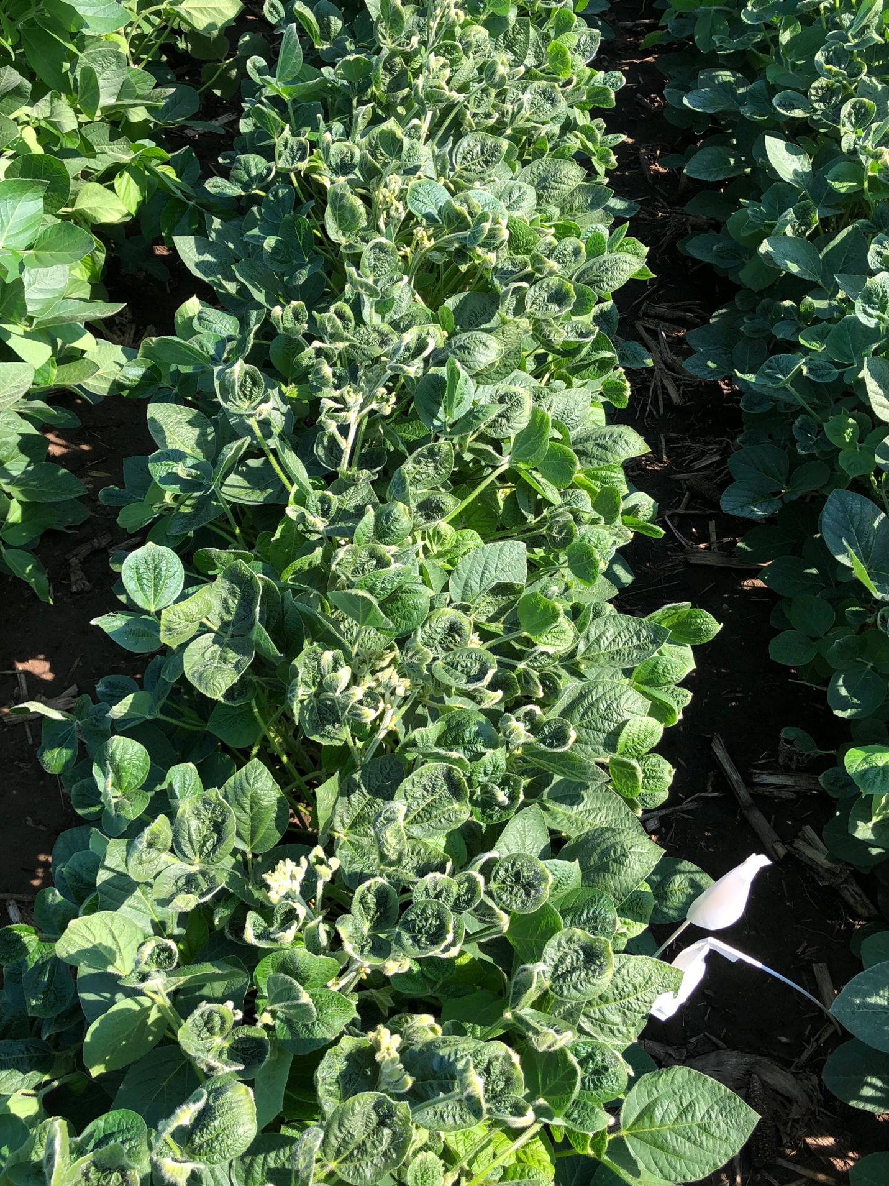

**XtendiMax w/Vaporgrip + PowerMax**

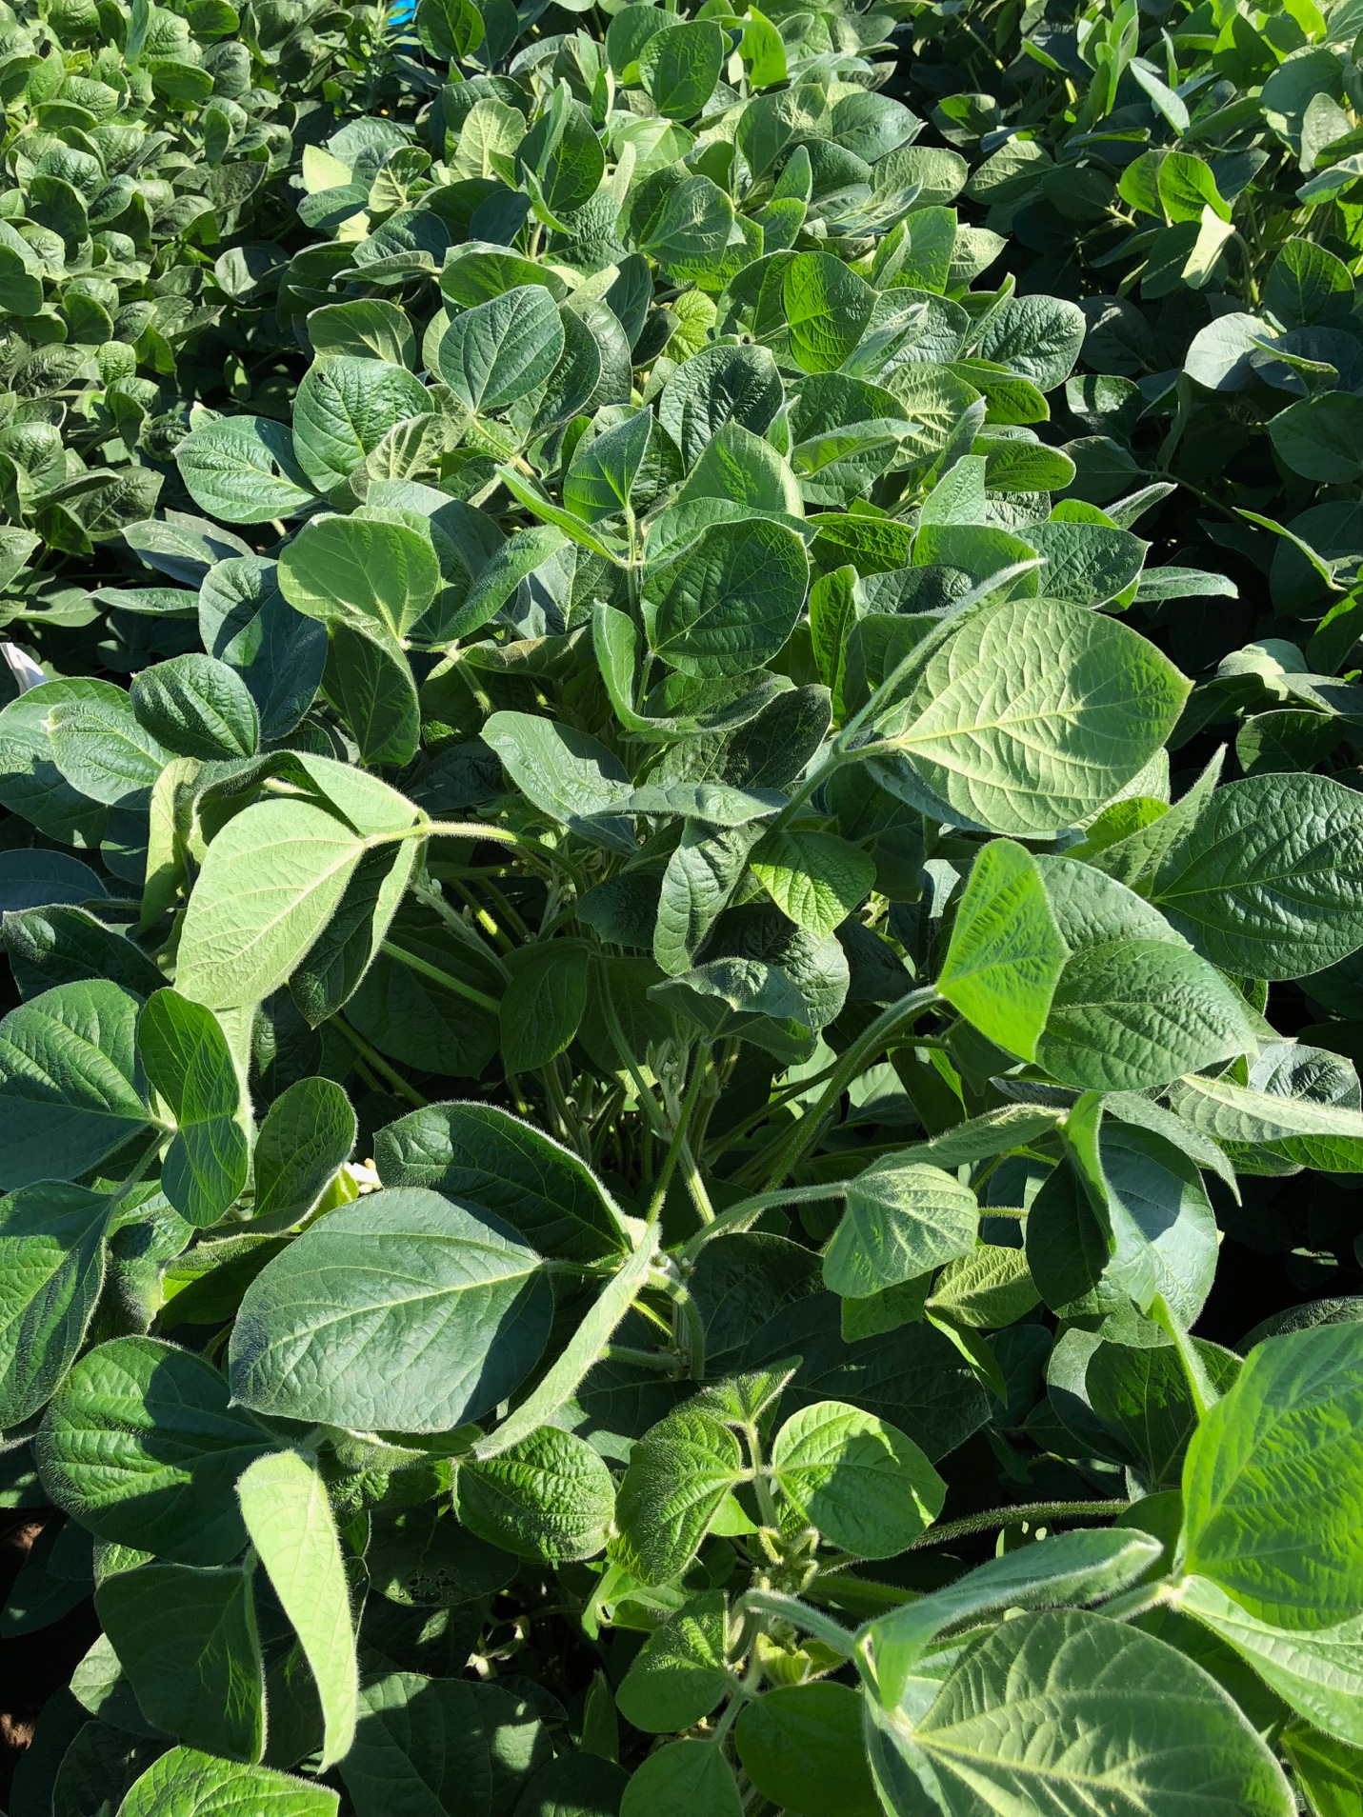

**XtendiMax w/Vaporgrip + PowerMax + Intact**

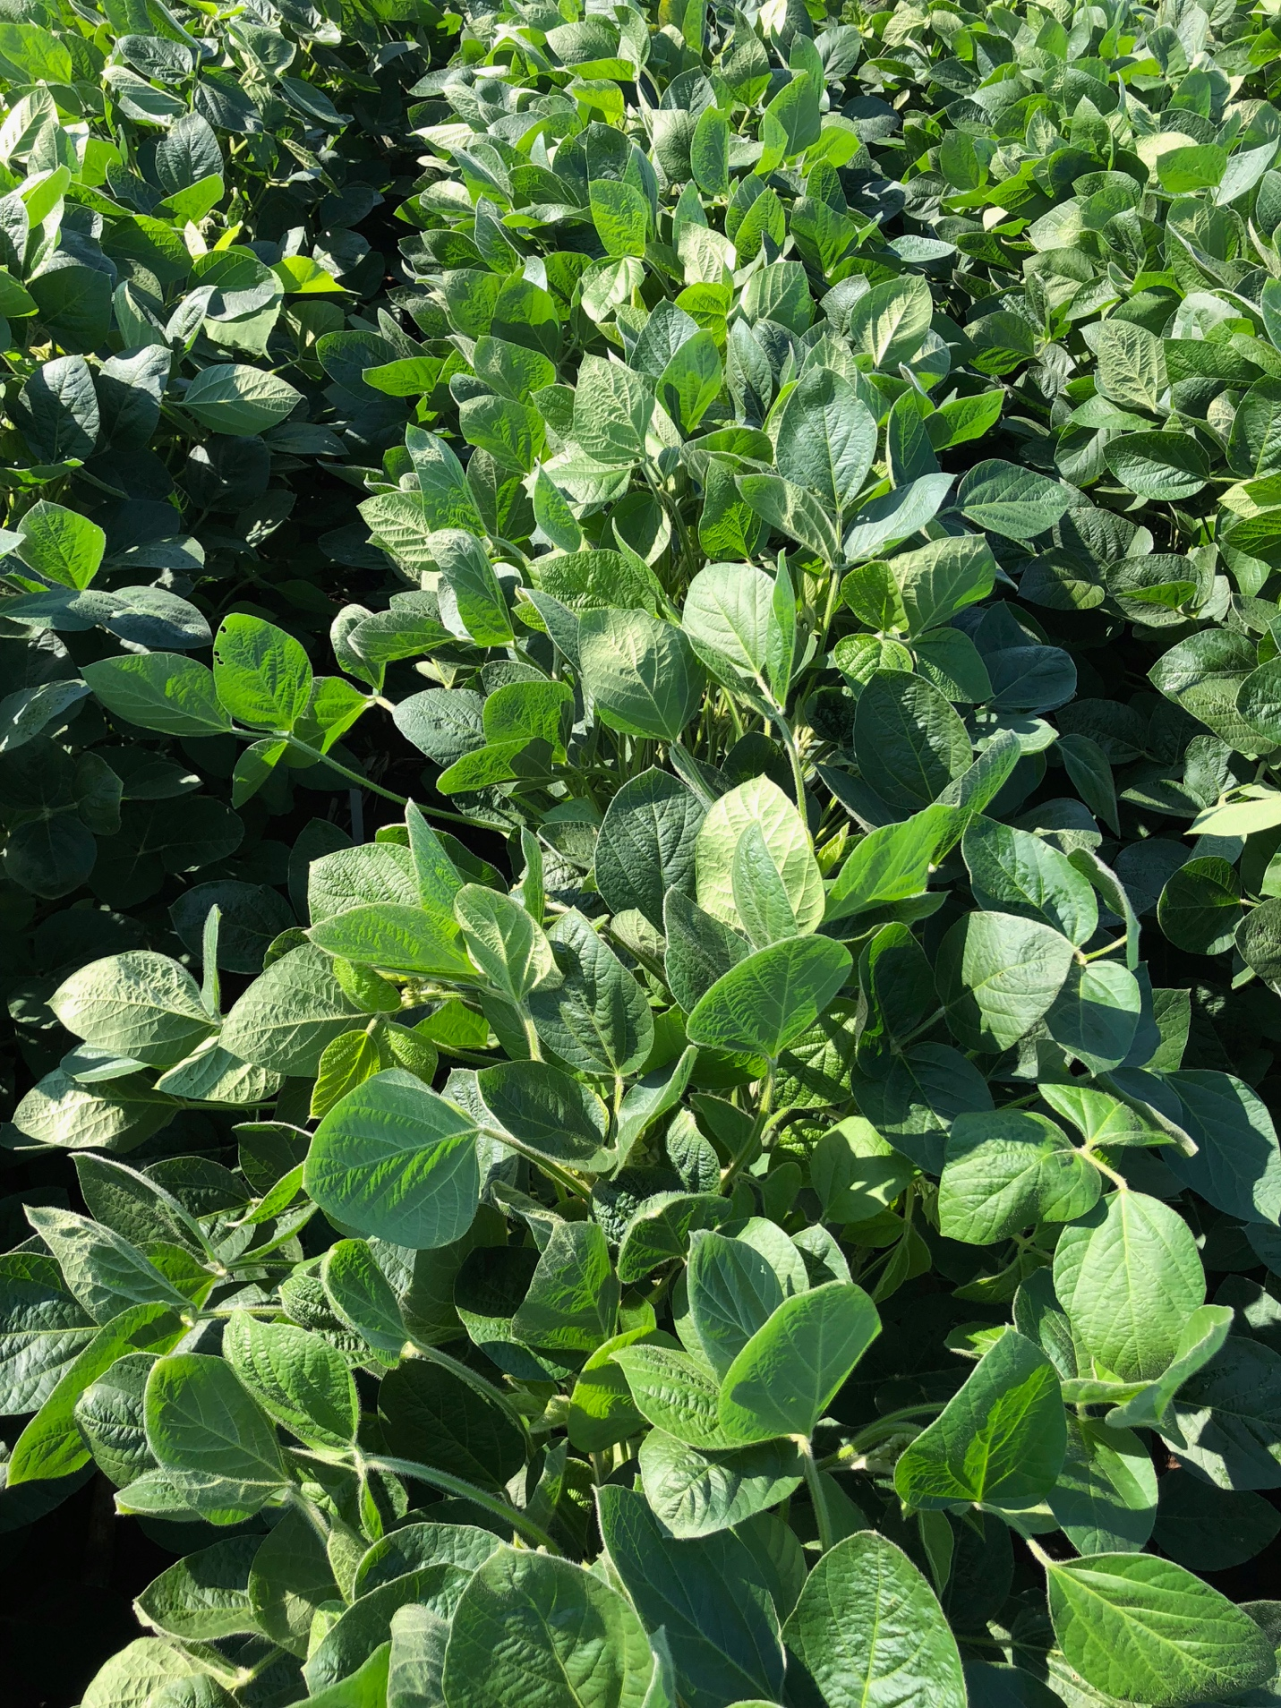

**XtendiMax w/Vaporgrip + PowerMax + Intact + Mon-10**

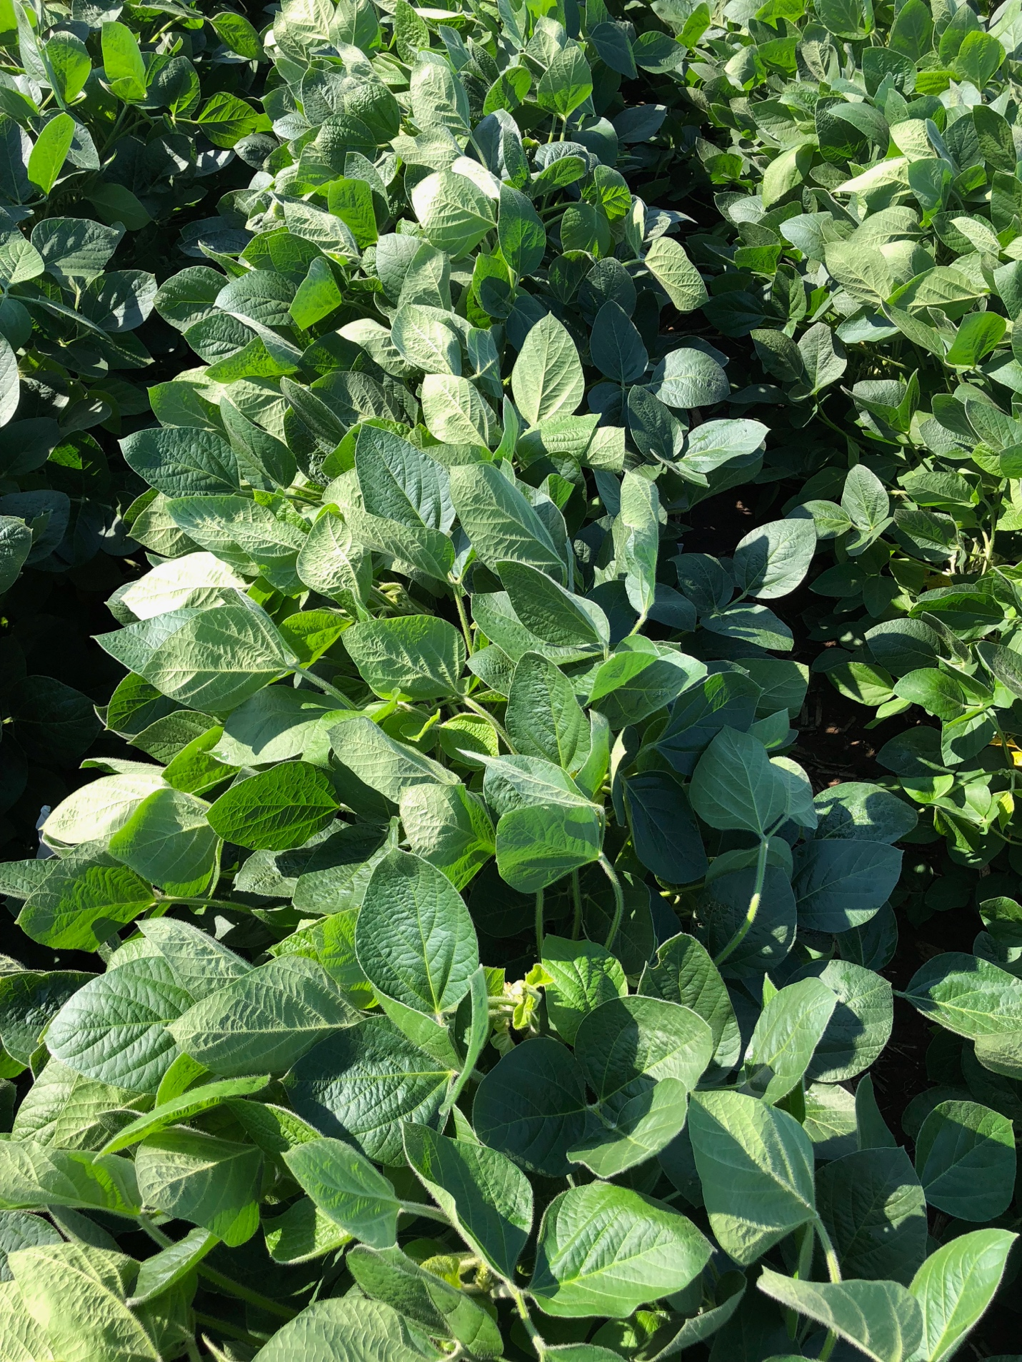

**Mon 76981 – RupXtend**

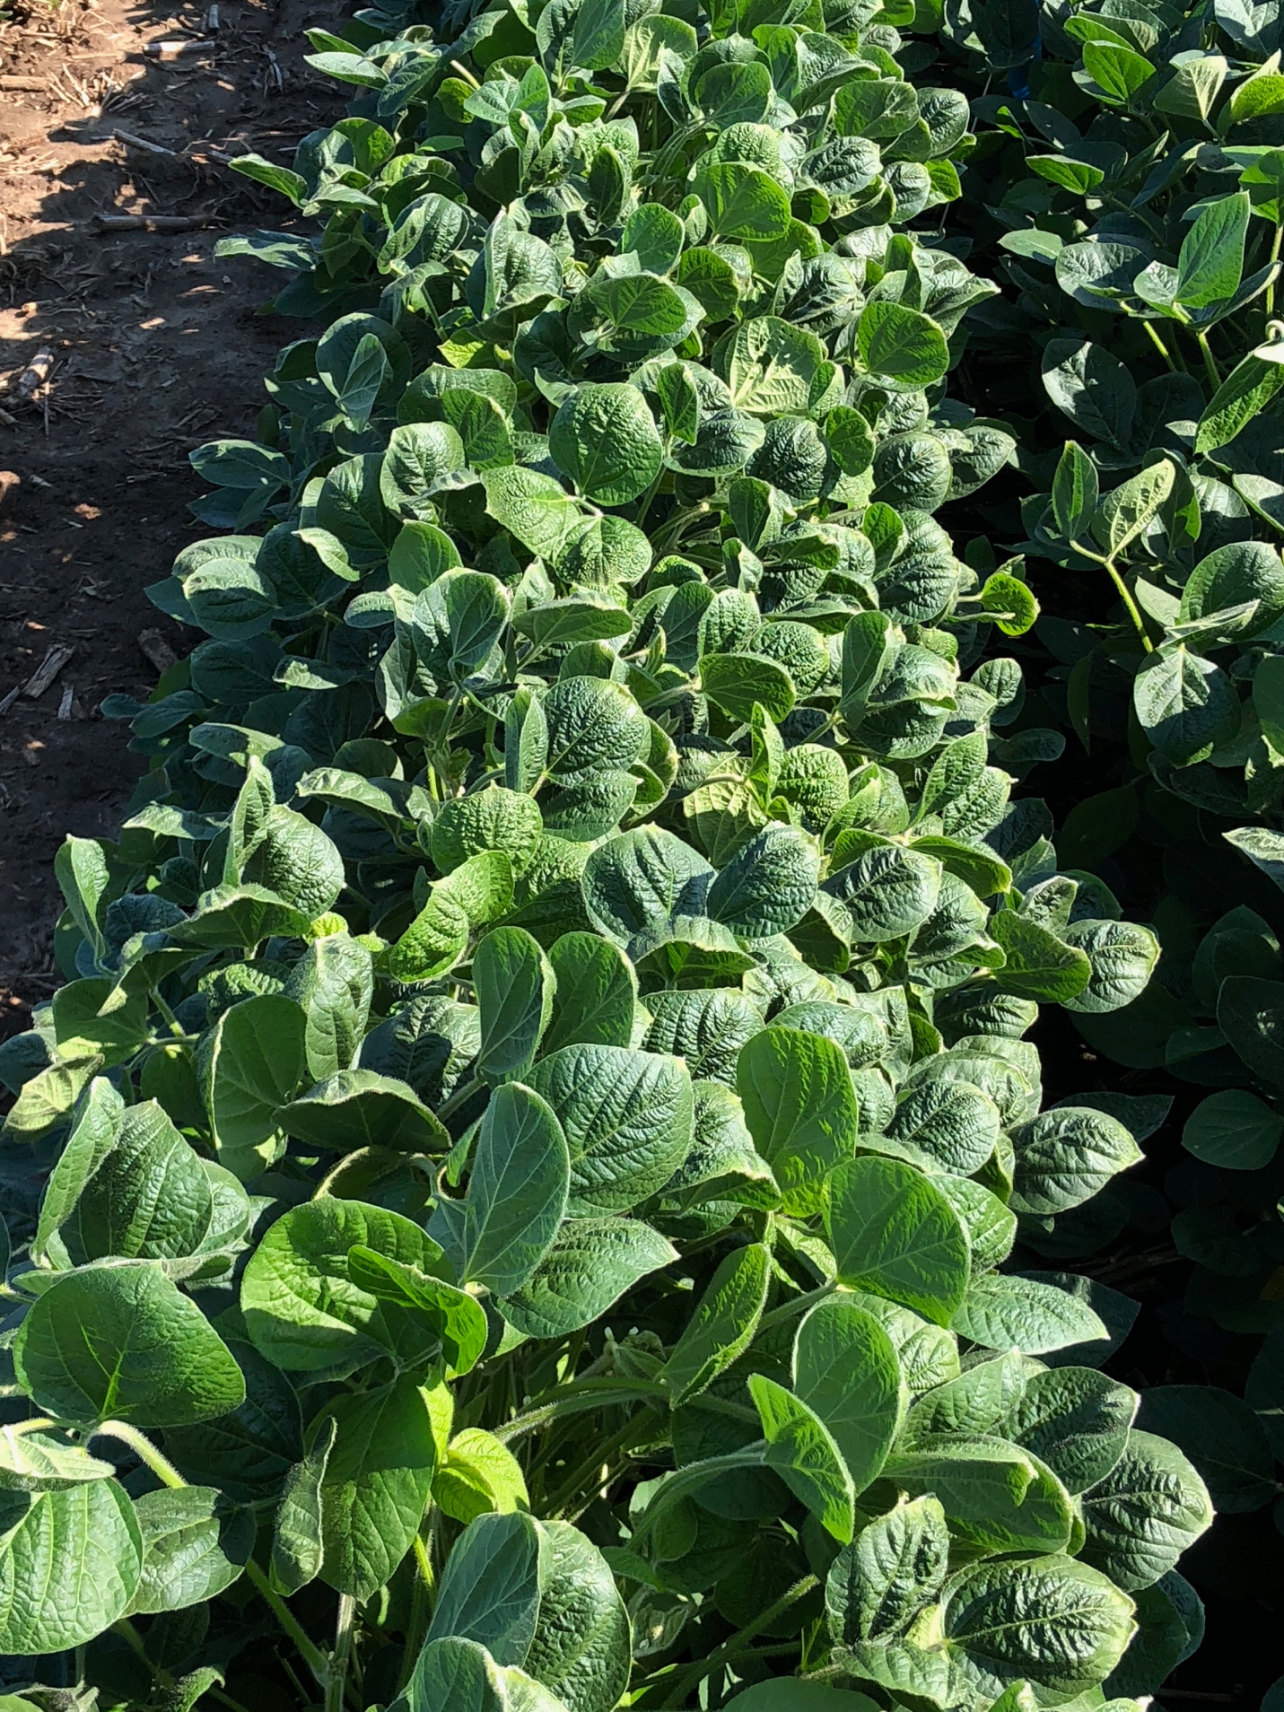

**Mon 76981 – RupXtend + Liberty**

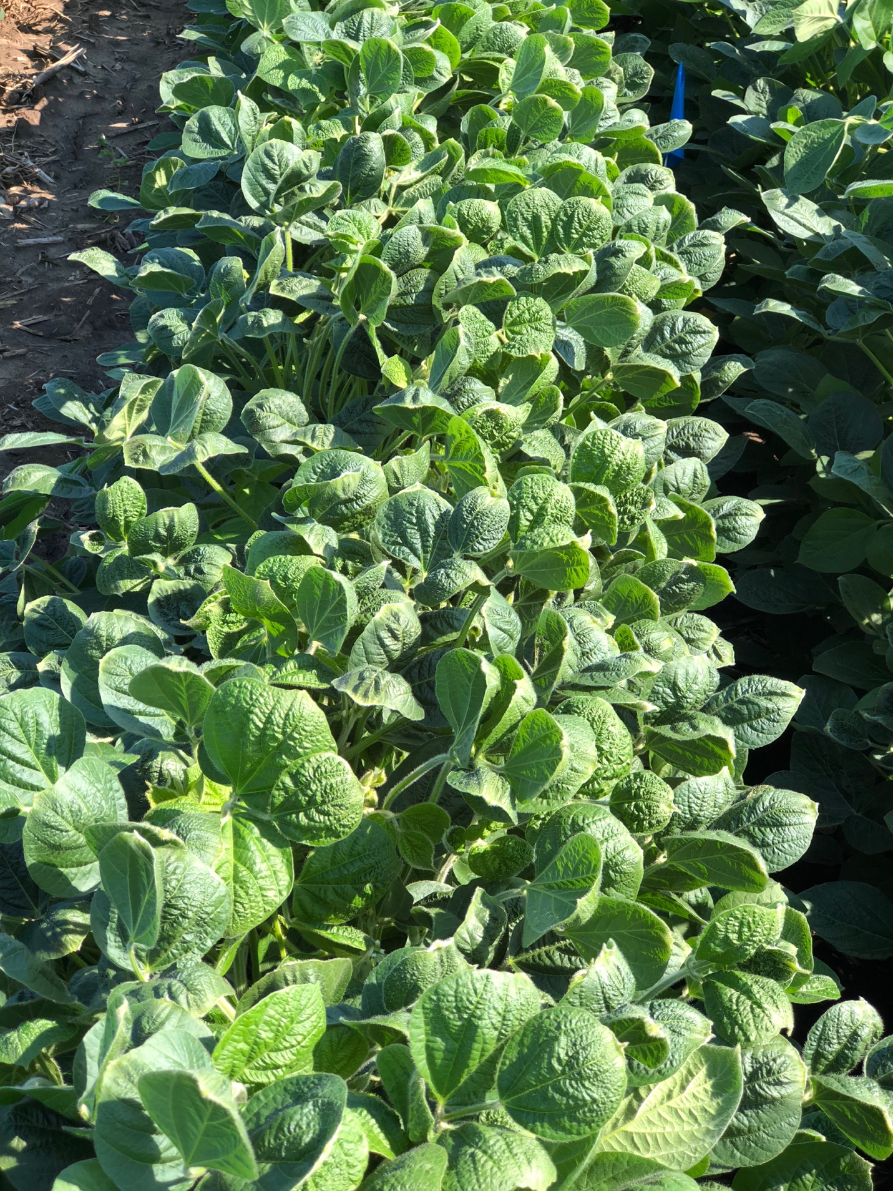

**Untreated**

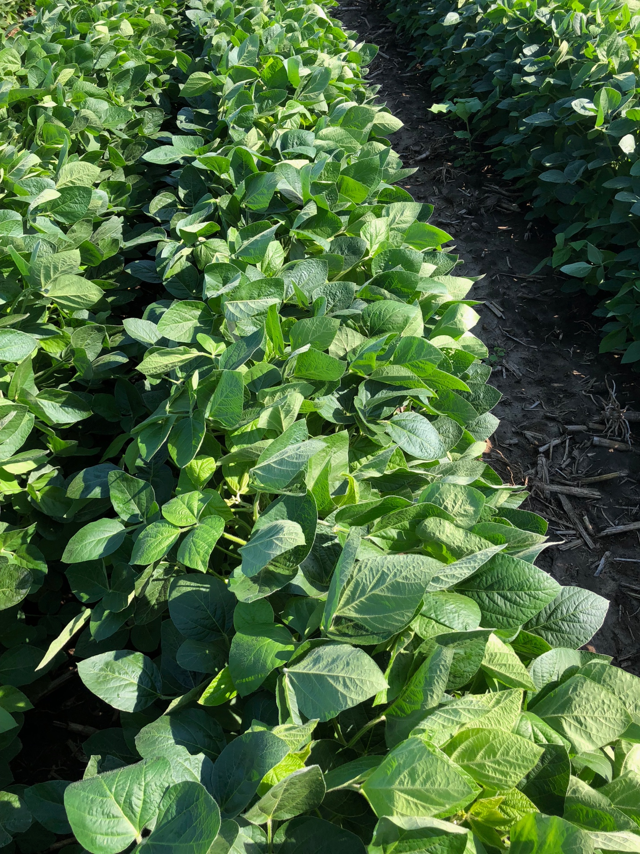

**Monsanto Dicamba Volatility Low-Tunnel 2**

Planted: 5/26/18

PRE: 6/1/18

Application (Flat): 07/03

Results presented at 14 and 28 DAT (days after treatment)

Photos taken at 28 DAT.

**V3-V4**

**21 cm**





**XtendiMax + PowerMax**

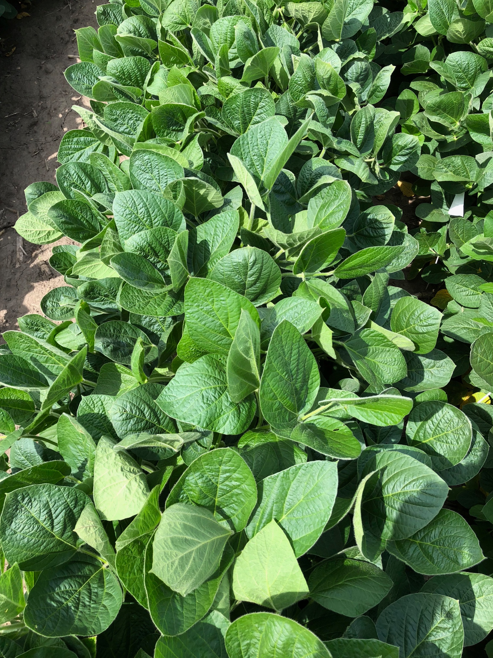

**XtendiMax II + PowerMax**

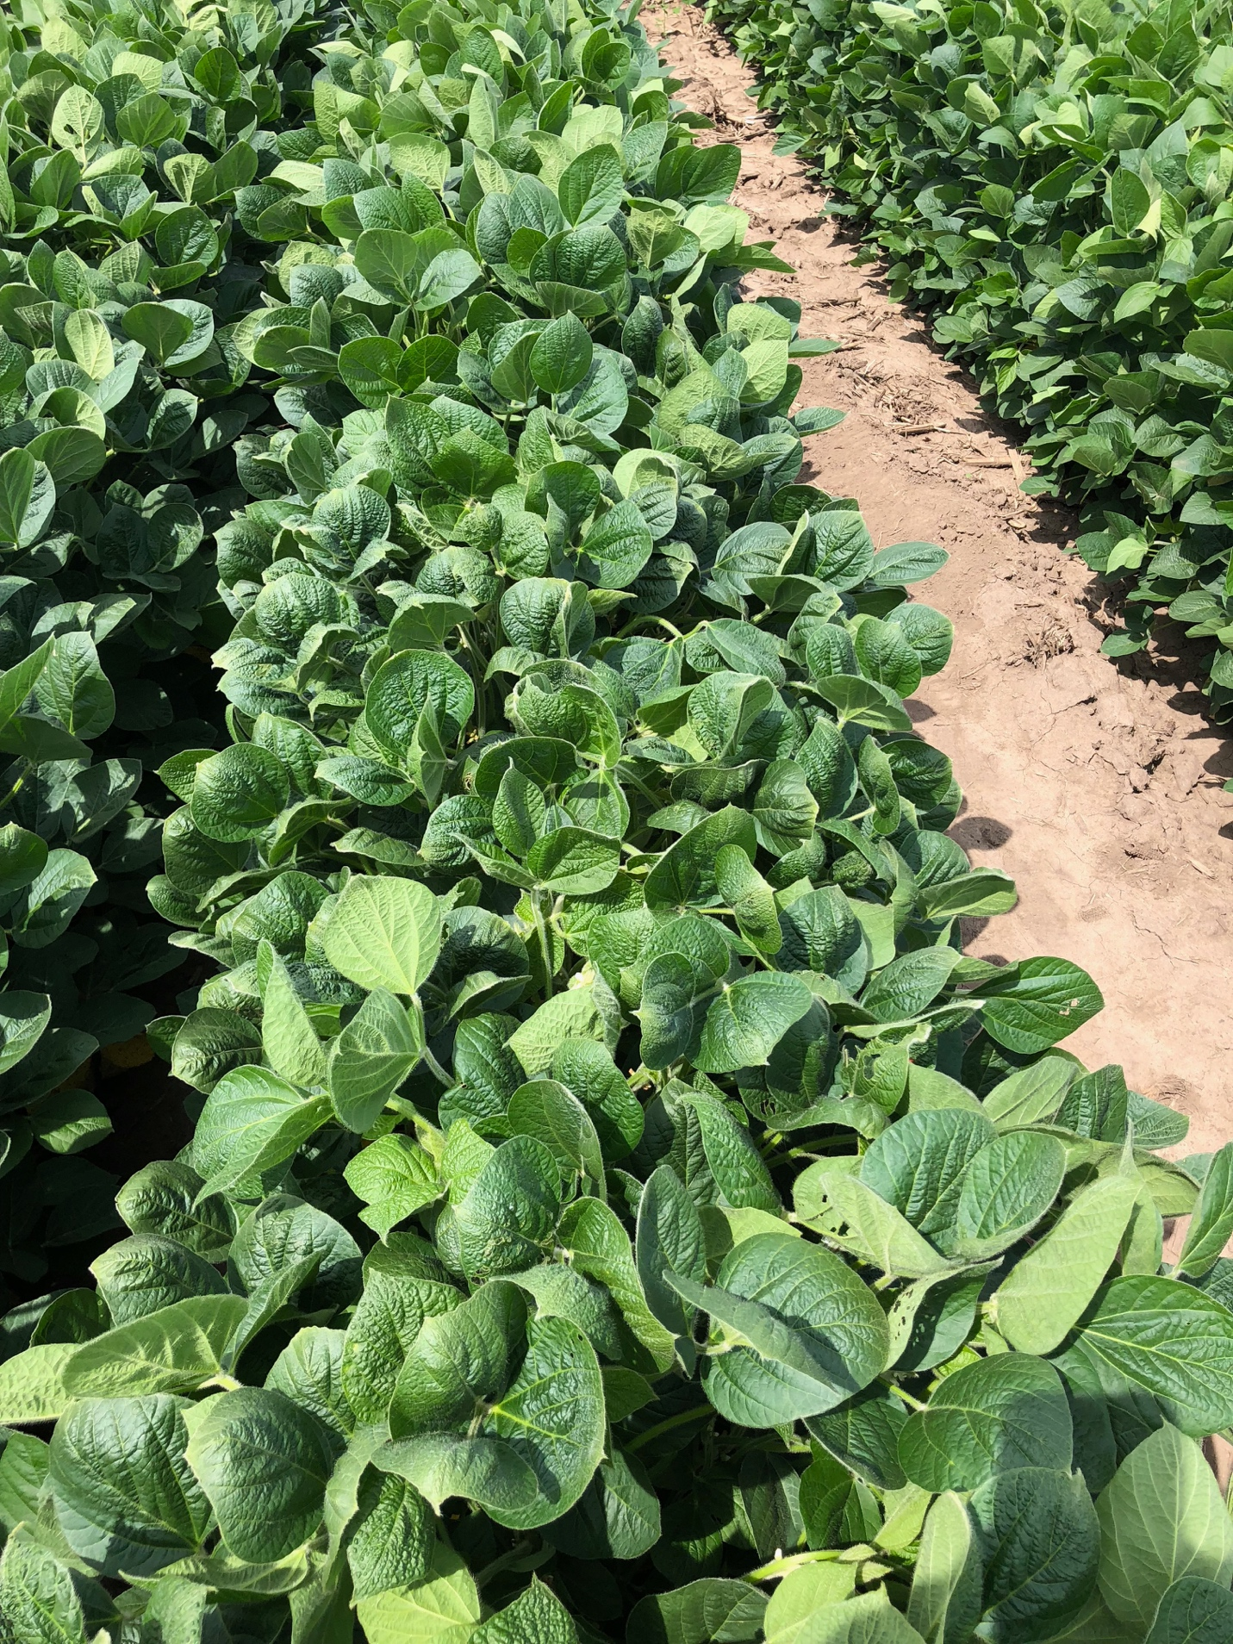

**RupXtend VGrip**

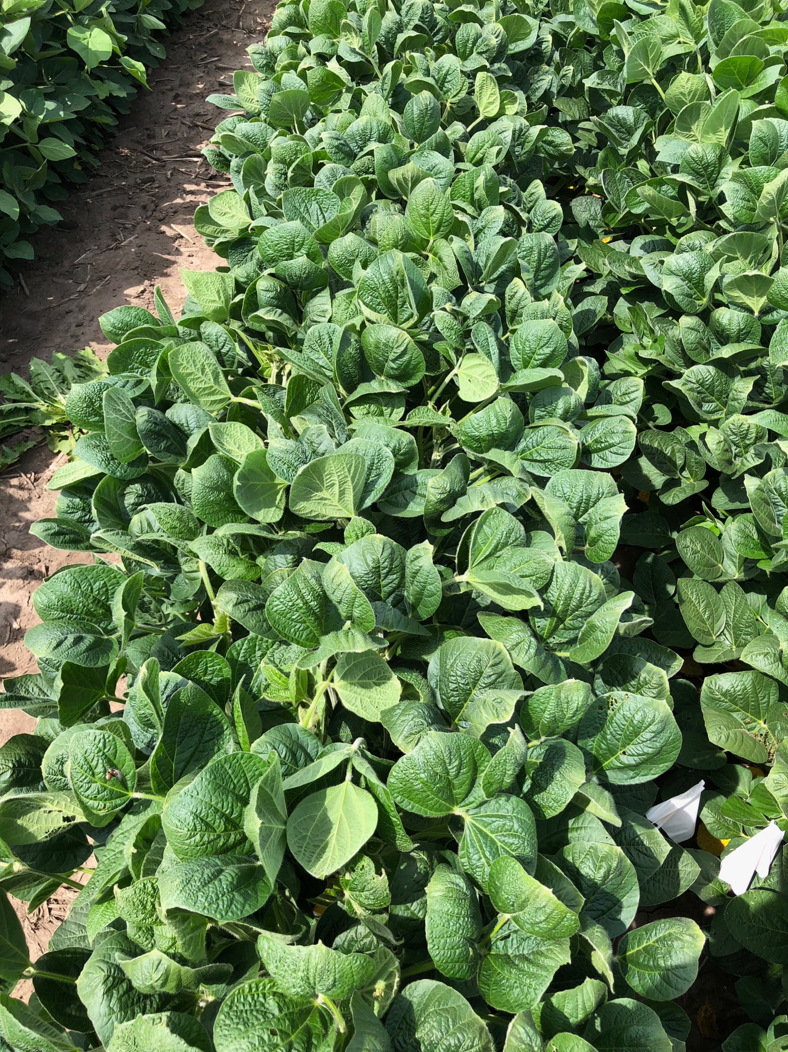

**RupXtend II VGrip**

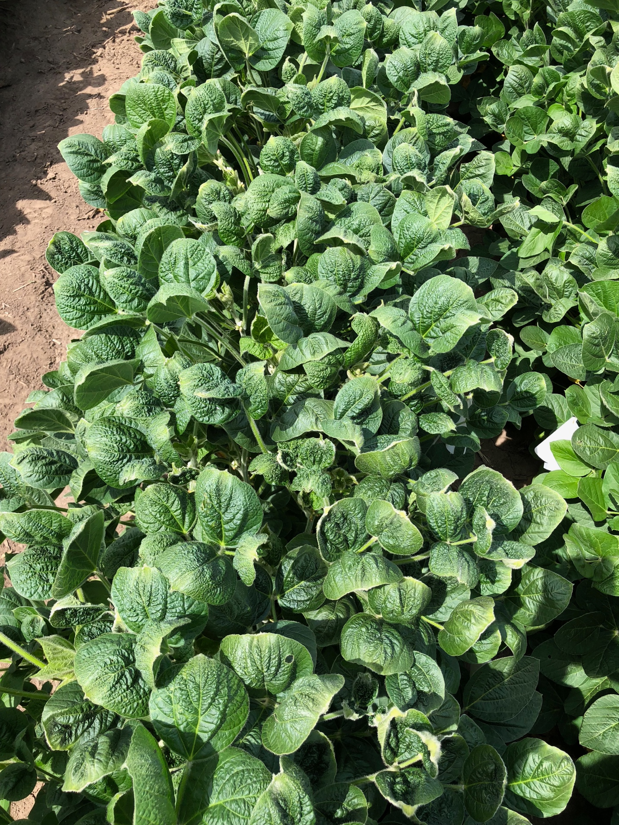

**RupXtend II VGrip + Liberty**

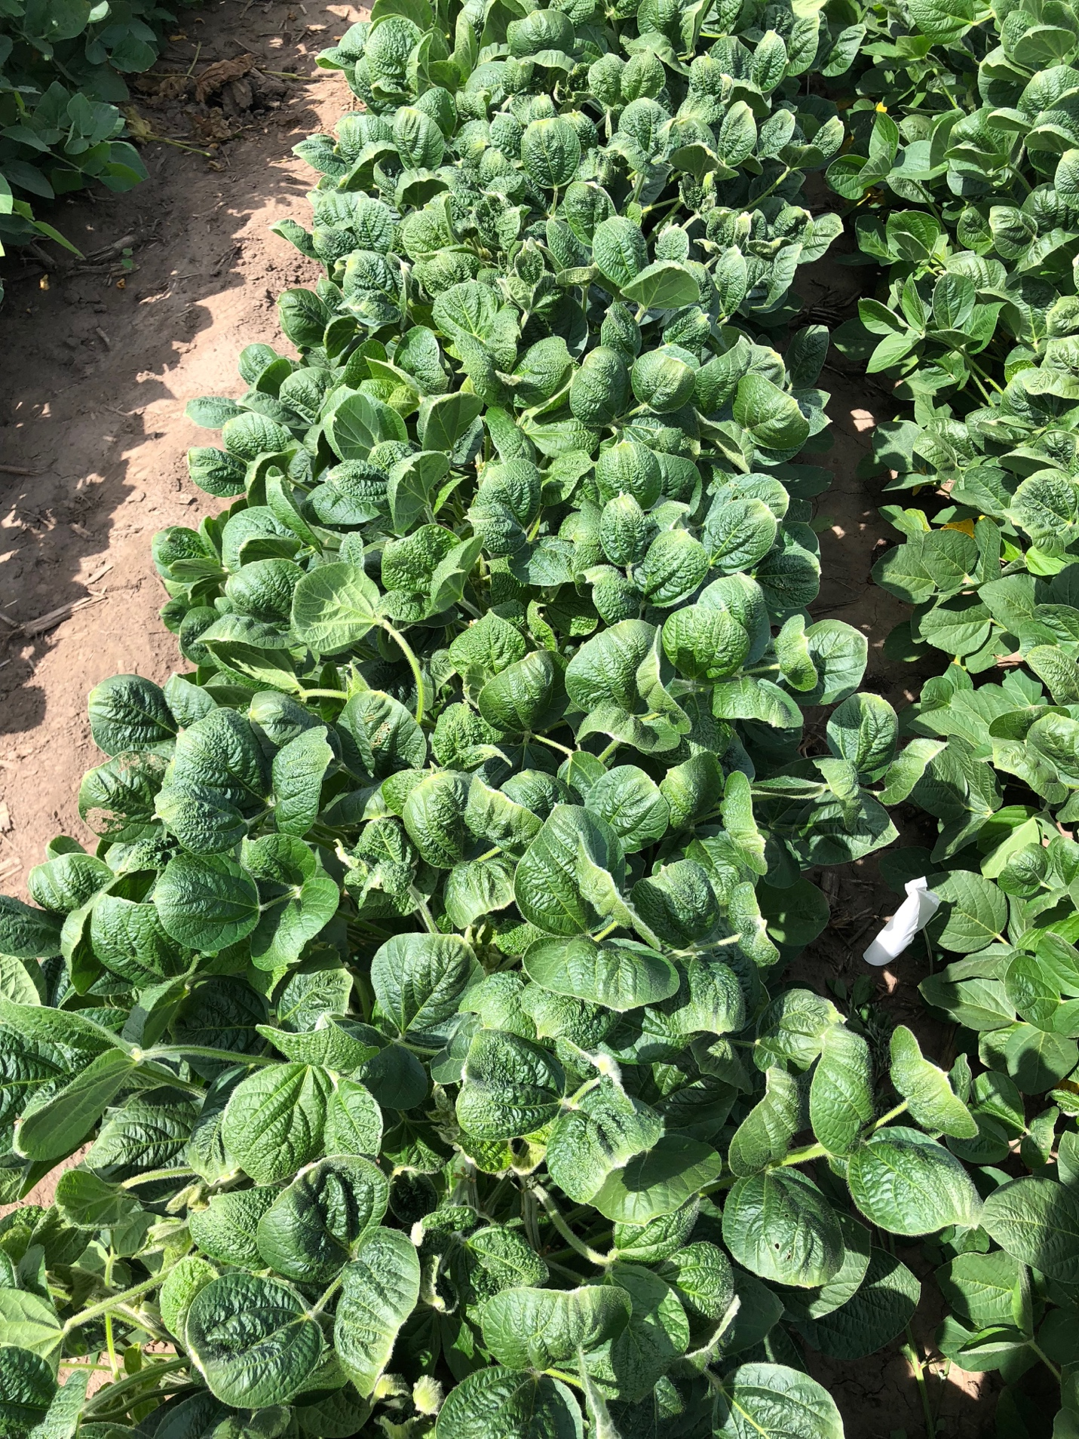

**Untreated**

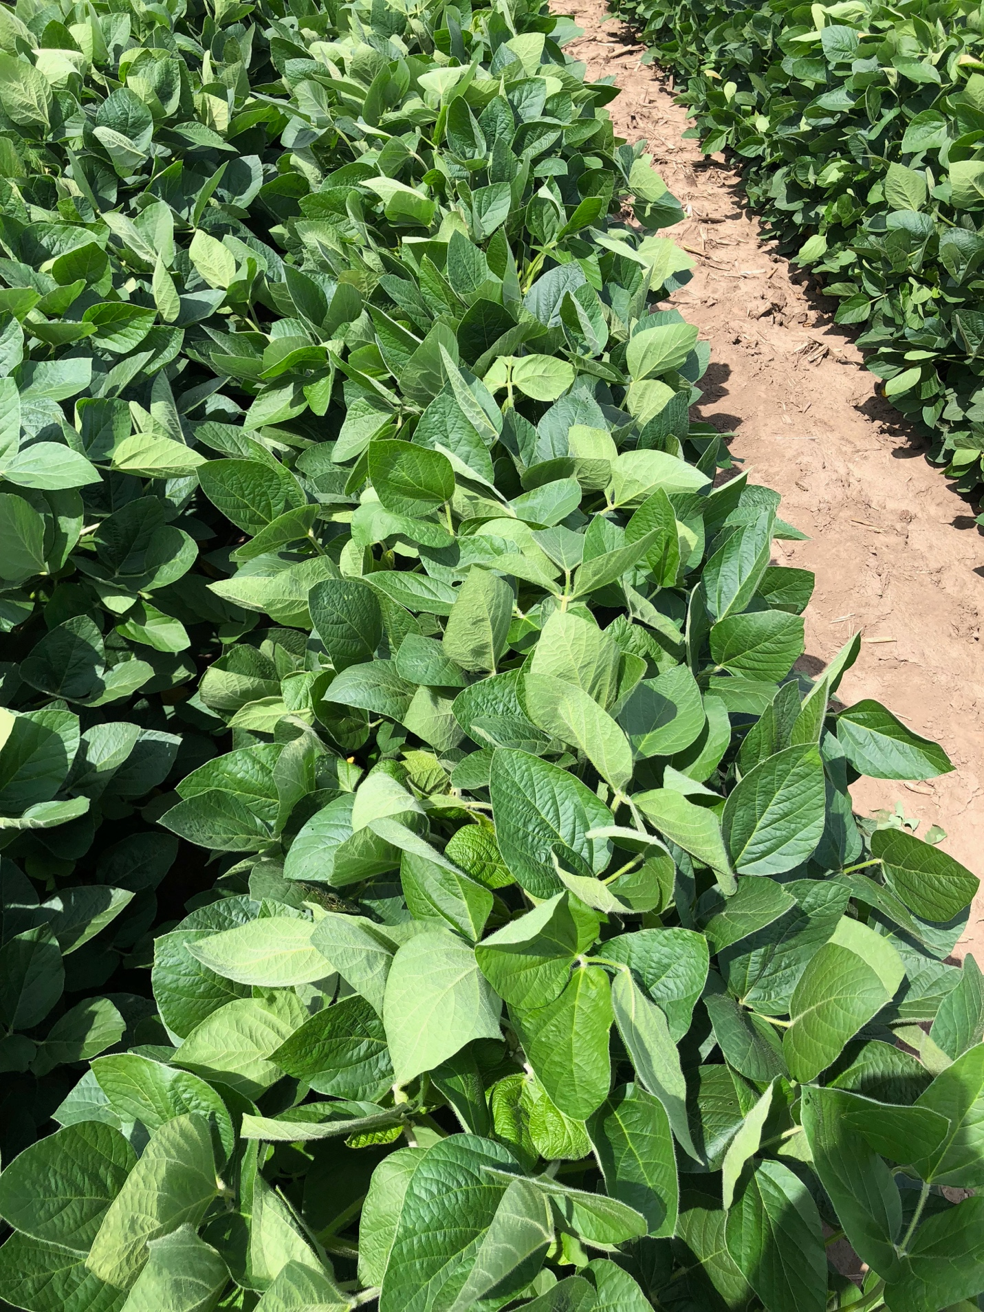

**Monsanto Dicamba Volatility Low-Tunnel 3**

Planted: 5/26/18

PRE: 6/1/18

Application (Flat): 07/08/2018

Results presented at 14 and 28 DAT (days after treatment)

Photos taken at 28 DAT.





**XtendiMax w/Vaporgrip + Warrant**

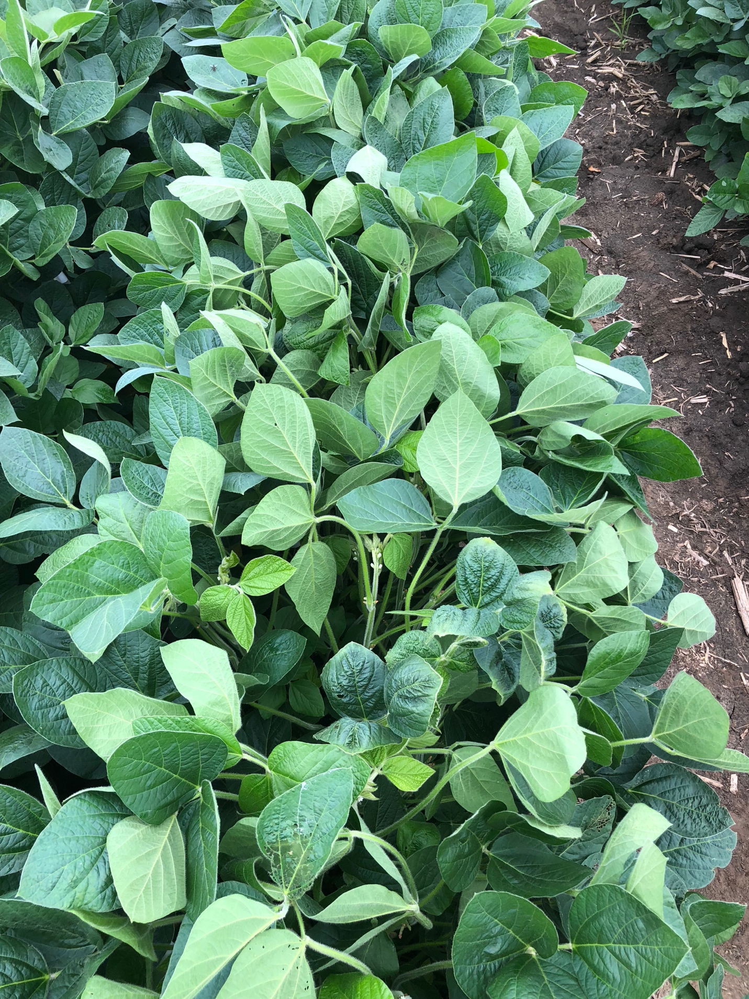

**XtendiMax w/Vaporgrip + Warrant + PowerMax**

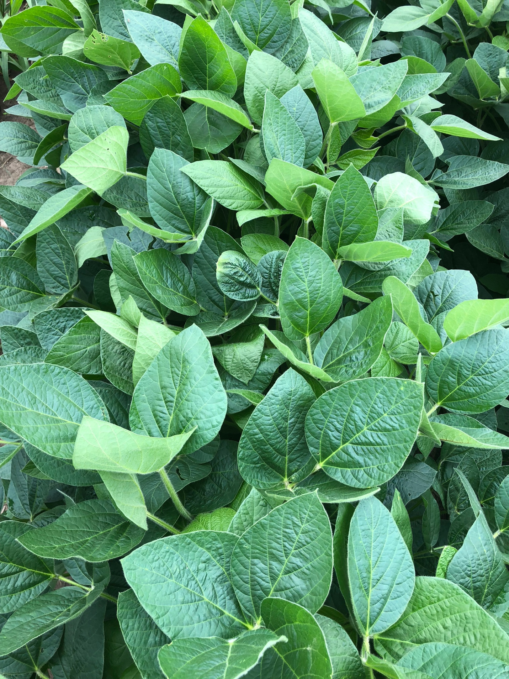

**Mon 304940**

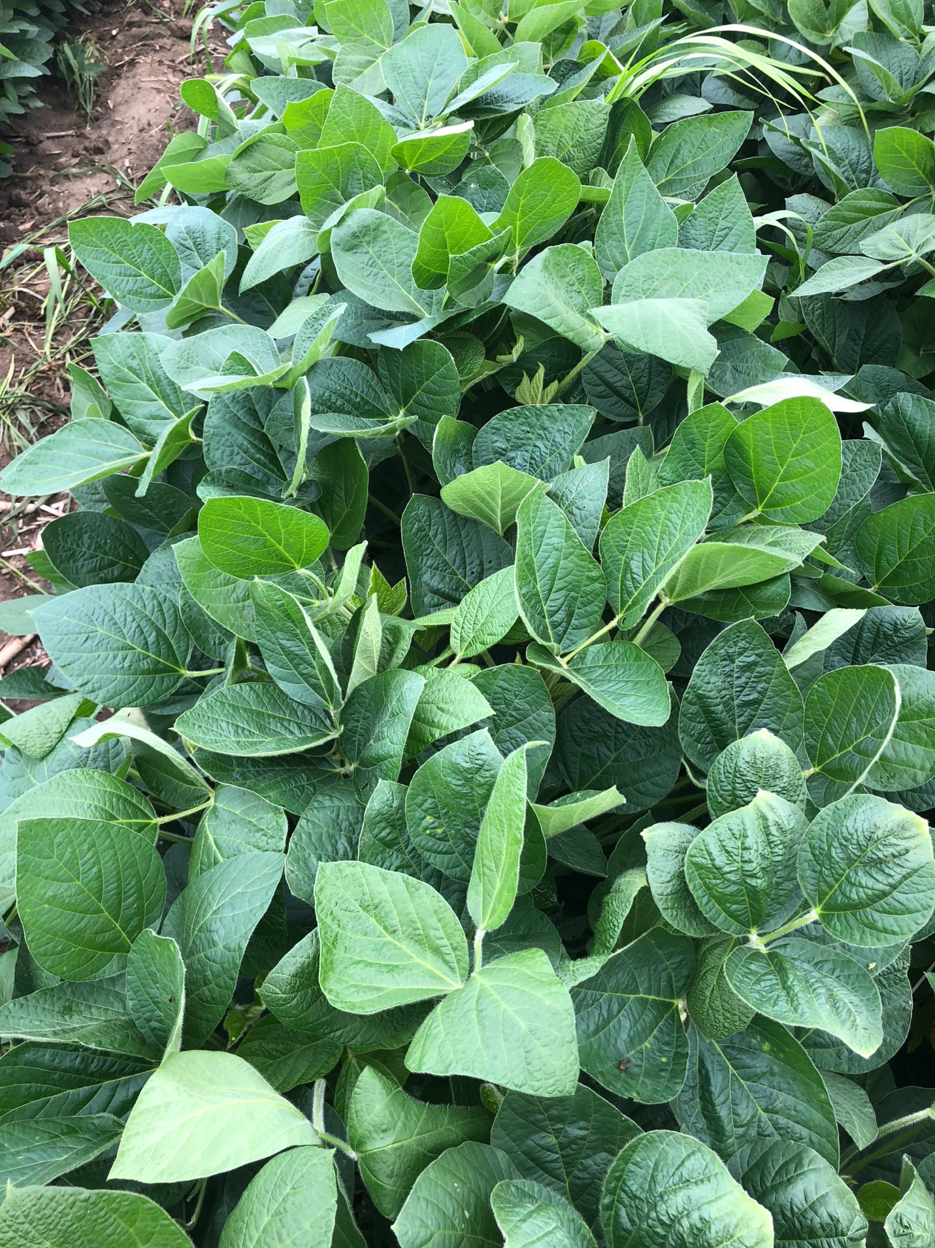

**Mon 304940 + PowerMax**

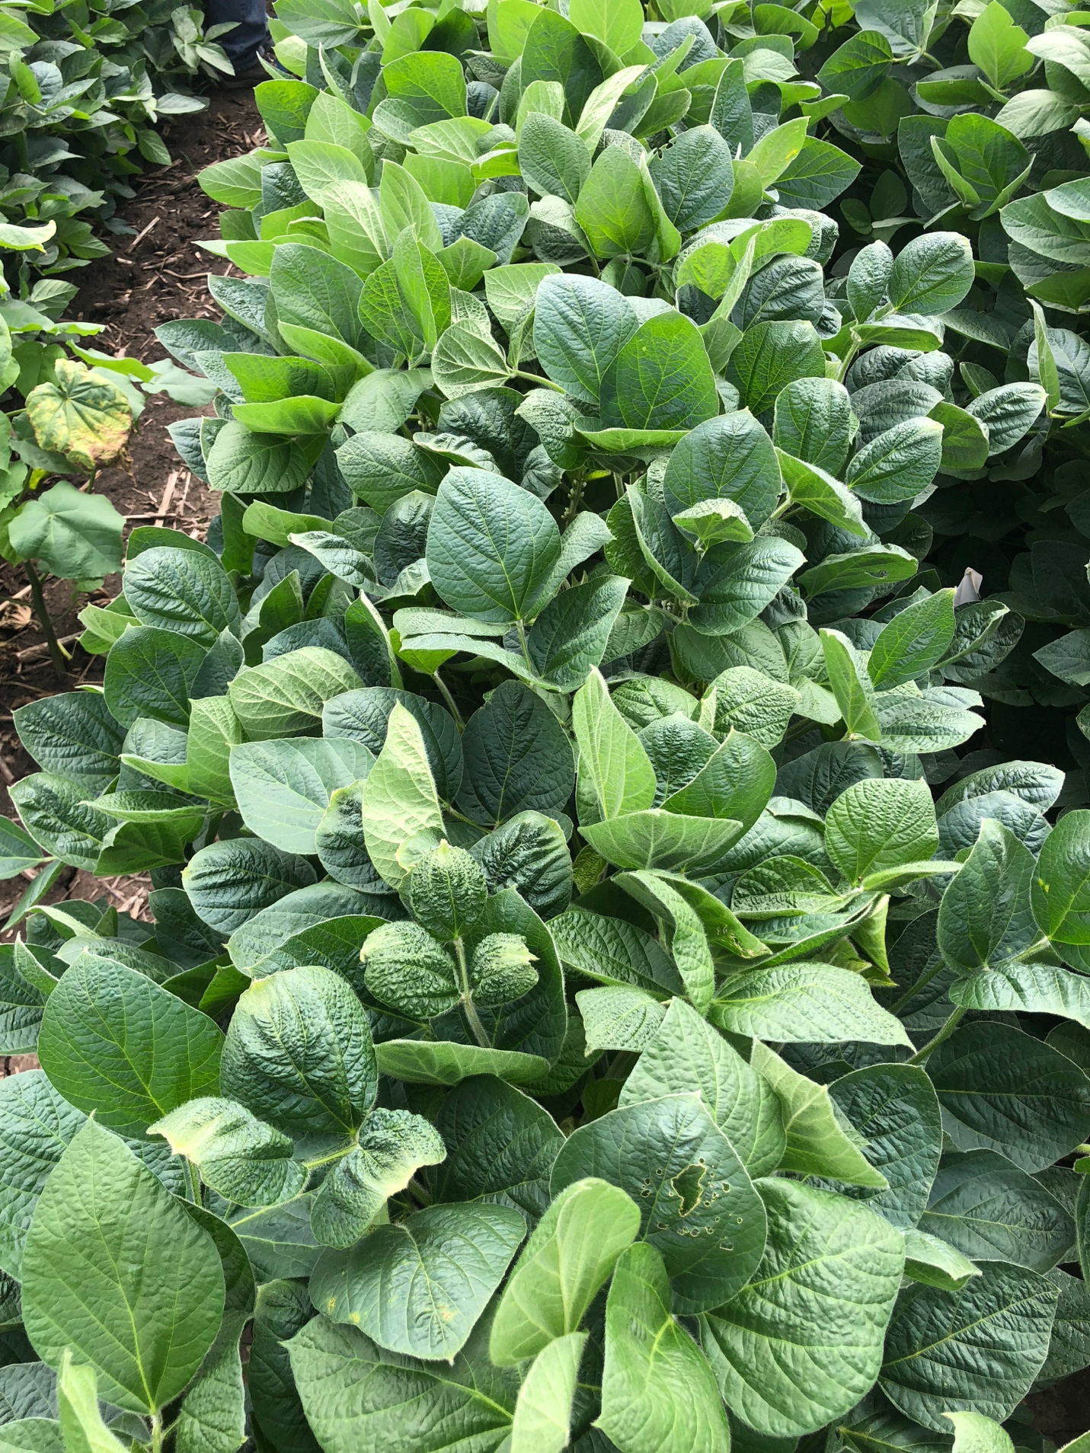

**Mon 301372**



**Mon 301372 + PowerMax**

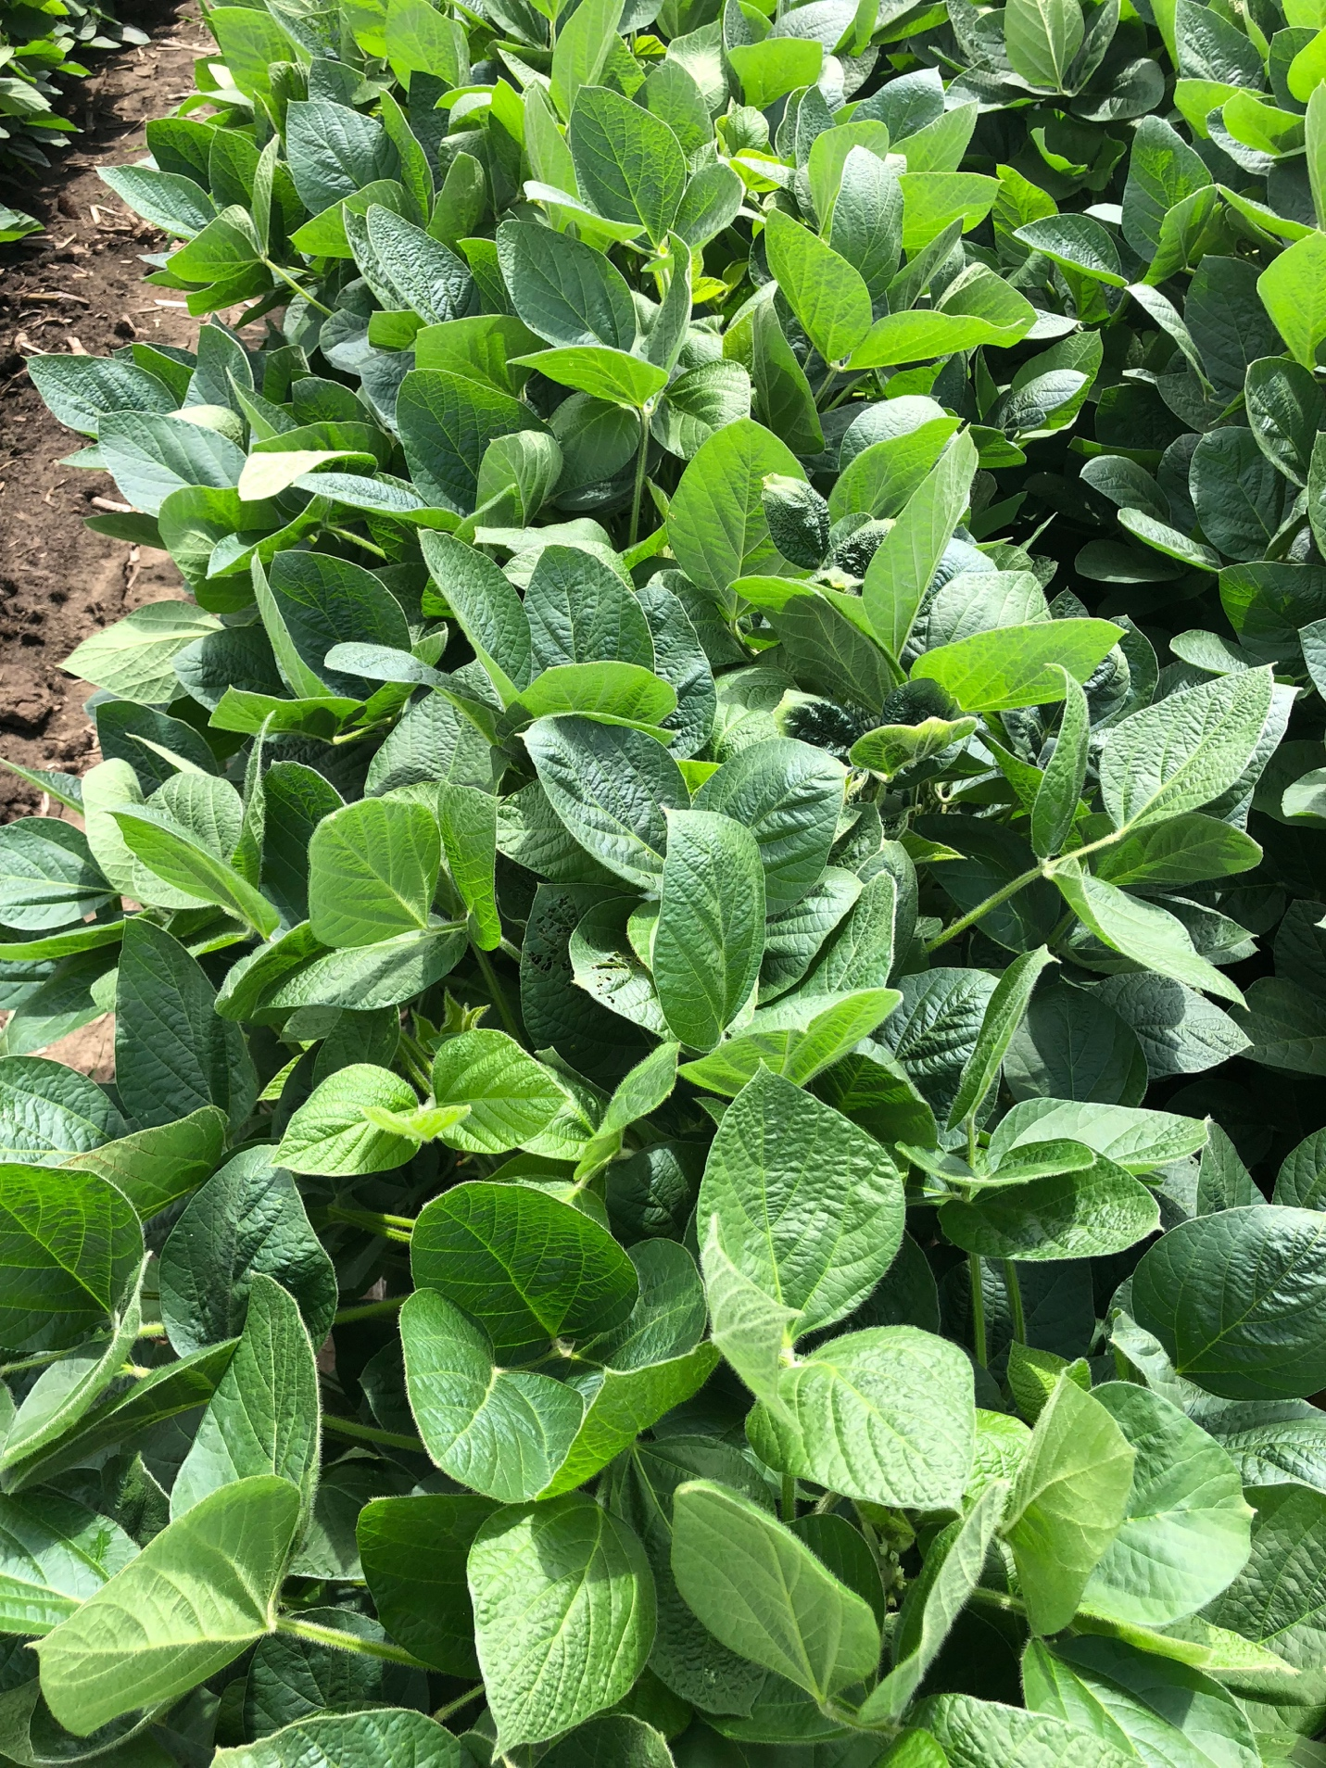

**Untreated**

